Name:___________________________________
English 8-_____
Kostopoulos
A Midsummer Night’s Dream by William Shakespeare
Ovid’s “Pyramus and Thisbe” translated by Thomas Bullfinch
Pre-reading:
Two teenagers fall madly in love, but their parents forbid them to see each other.
Sound familiar?

Defying their families, they plan to run away together, but a series of misunderstandings leads to their disastrous demise.
Sound familiar?

Some stories are so universally appealing that they appear over and over, in everything from ancient myths to Shakespearean drama to modern soap operas. “Pyramus and Thisbe” is one of these classic stories. It is also the “play-within-a-play” in A Midsummer Night’s Dream.

“Pyramus and Thisbe” is taken from the Metamorphoses, Ovid’s masterpiece. Ovid is considered to be one of the greatest poets of antiquity. A long narrative poem, the Metamorphoses retells many of the most important myths from Ancient Greece and Rome. Ovid breathed new life into the old stories. Ovid’s retellings have inspired writers for centuries – including William Shakespeare.

Essential Literary Items to Think About:

“Pyramus and Thisbe” is a classic myth, here retold in prose. Myths with enduring messages are often retold; many are even updated in more modern forms such as novels and films. As you read this myth, notice what it attempts to explain. Also, consider the lesson the myth teaches about the value of love.

“Pyramus and Thisbe” shows the unfortunate result that can happen to young lovers caught up in their passions.

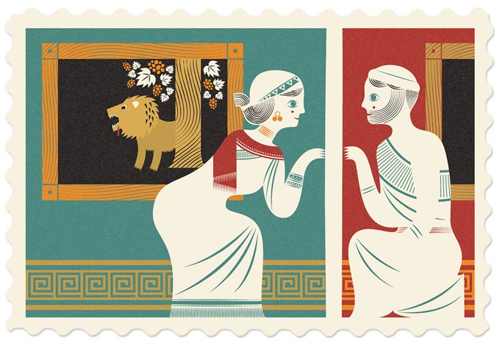
The tragic action in “Pyramus and Thisbe” all takes place in two days.

Why do you think Shakespeare chose to include this myth in his play A Midsummer Night’s Dream? Let’s try and find out!
TASK: We will read each section of the story together.
Afterward, you and your partner(s) answer the questions that follow.
Use complete sentences and examples/words from the text to support your answer.

Pyramus was the handsomest youth, and Thisbe the fairest maiden, in all Babylonia, where Semiramis reigned. Their parents occupied adjoining houses; and neighborhood brought the young people together, and acquaintance ripened into love. They would gladly have married, but their parents forbade. One thing, however, they could not forbid - that love should glow with equal ardor (intense love) in the bosoms of both. They conversed by signs and glances, and the fire burned more intensely for being covered up.

How are Pyramus and Thisbe described?

What is their relationship like?

What parallels do you see so far between this myth and A Midsummer Night’s Dream?

In the wall that parted the two houses there was a crack, caused by some fault in the structure. No one had remarked it before, but the lovers discovered it. What will love not discover! It afforded a passage to the voice; and tender messages used to pass backward and forward through the gap. As they stood, Pyramus on his side, Thisbe on that, their breaths would mingle. "Cruel wall," they said, "why do you keep two lovers apart? But we will not be ungrateful. We owe you, we confess, the privilege of transmitting loving words to willing ears." Such words they uttered on different sides of the wall; and when night came and they must say farewell, they pressed their lips upon the wall, she on her side, he on his, as they could come no nearer.

How do Pyramus and Thisbe communicate after their parents have forbidden their love?

Next morning, when Eos had put out the stars, and the sun had melted the frost from the grass, they met at the accustomed spot. Then, after lamenting (mourning) their hard fate, they agreed that next night, when all was still, they would slip away from watchful eyes, leave their dwellings and walk out into the fields; and to insure a meeting, repair (come back together again) to a well-known edifice (building) standing without the city's bounds, called the Tomb of Ninus, and that the one who came first should await the other at the foot of a certain tree. It was a white mulberry tree, and stood near a cool spring.
What is Pyramus and Thisbe’s plan? Where and when do they decide to meet? Be specific.

Again, what parallels do you see so far between this myth and A Midsummer Night’s Dream?

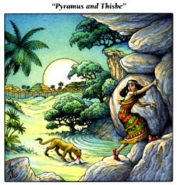
All was agreed on, and they waited impatiently for the sun to go down beneath the waters and night to rise up from them. Then cautiously Thisbe stole forth, unobserved by the family, her head covered with a veil, made her way to the monument and sat down under the tree. As she sat alone in the dim light of the evening she descried a lioness, her jaws reeking with recent slaughter, approaching the fountain to slake (satisfy, quench) her thirst. Thisbe fled at the sight, and sought refuge in the hollow of a rock. As she fled she dropped her veil. The lioness after drinking at the spring turned to retreat to the woods, and seeing the veil on the ground, tossed and rent (tore) it with her bloody mouth.

What incident happens to Thisbe as she is waiting under the tree for Pyramus?

What item does Thisbe drop on the ground?

Pyramus, having been delayed, now approached the place of meeting. He saw in the sand the footsteps of the lion, and the color fled from his cheeks at the sight. Presently he found the veil all rent (torn) and bloody. "O hapless girl," said he, "I have been the cause of thy death! Thou, more worthy of life than I, hast fallen the first victim. I will follow. I am the guilty cause, in tempting thee forth to a place of such peril, and not being myself on the spot to guard thee. Come forth, ye lions, from the rocks, and tear this guilty body with your teeth." He took up the veil, carried it with him to the appointed tree, and covered it with kisses and with tears. "My blood also shall stain your texture, " said he, and drawing his sword plunged it into his heart. The blood spurted from the wound, and tinged the white mulberries of the tree all red; and sinking into the earth reached the roots, so that the red color mounted through the trunk to the fruit.

What does Pyramus think has happened to Thisbe? Why does he think this?

Why does Pyramus blame himself for bringing harm to Thisbe?

What action does Pyramus perform when he thinks Thisbe is dead?

By this time Thisbe, still trembling with fear, yet wishing not to disappoint her lover, stepped cautiously forth, looking anxiously for the youth, eager to tell him the danger she had escaped. When she came to the spot and saw the changed color of the mulberries she doubted whether it was the same place. While she hesitated she saw the form of one struggling in agonies of death. She started back, a shudder ran through her frame as a ripple on the face of the still water when a sudden breeze sweeps over it.

But as soon as she recognized her lover, she screamed and beat her breast, embracing the lifeless body, pouring tears into its wounds, and imprinting kisses on the cold lips. "O Pyramus," she cried, "what has done this? Answer me, Pyramus; it is your own Thisbe that speaks. Hear me, dearest, and lift that drooping head!" At the name of Thisbe, Pyramus opened his eyes, then closed them again. She saw her veil stained with blood and the scabbard (cover) empty of its sword. "Thy own hand has slain thee, and for my sake, " she said. "I too can be brave for once, and my love is as strong as thine. I will follow thee in death, for I have been the cause; and death which alone could part us shall not prevent my joining thee. And ye, unhappy parents of us both, deny us not our united request. As love and death have joined us, let one tomb contain us. And thou, tree, retain the marks of slaughter. Let thy berries still serve for memorials of our blood." So saying she plunged the sword into her breast. Her parents ratified (formally approved) her wish, the gods also ratified it. The two bodies were buried in one sepulcher (tomb), and the tree ever after brought forth purple berries, as it does to this day.

When Thisbe returns and finds Pyramus, what does she do?

What is Thisbe’s final request to her parents? Explain.

MYTH EXTENSION: According to Ovid, why does the mulberry tree produce deep red berries as a result of the lovers’ tragedy?

HOMEWORK:
Use complete sentences and examples/words from the text to support your answer.

1. What differences do you see, so far, between the play and the myth?

2. If given the chance, what advice would you have given to Pyramus or Thisbe or both?

3. What do both Shakespeare and Ovid have to say about obsession and love?

4. Why do you think Shakespeare chose to include this “play-within-a-play” in A Midsummer Night’s Dream? How is it a warning for the young lovers in the play?

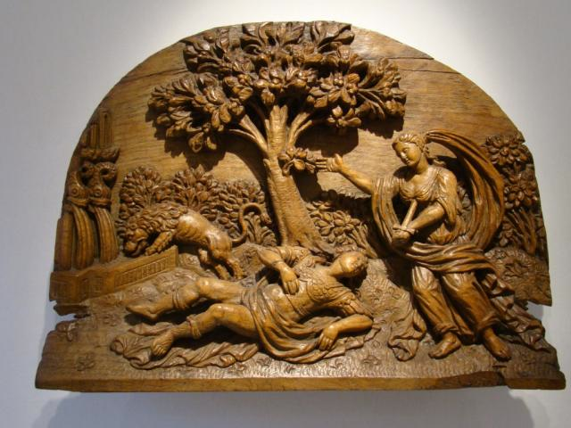

SELF SELECT:
5. What does this play teach us about the value of love?

